MANUAL - PPMP
ANNUAL PROCUREMENT PLAN (APP)
➡️ A yearly roadmap of all intended purchases, including items, quantities, costs, and schedules.

① CREATE OFFICE PPMP (Project Procurement Management Plan)
➡️ The PPMPs from each office are collected and imported on this page (Excel File).
Navigate the Page to Create office PPMP
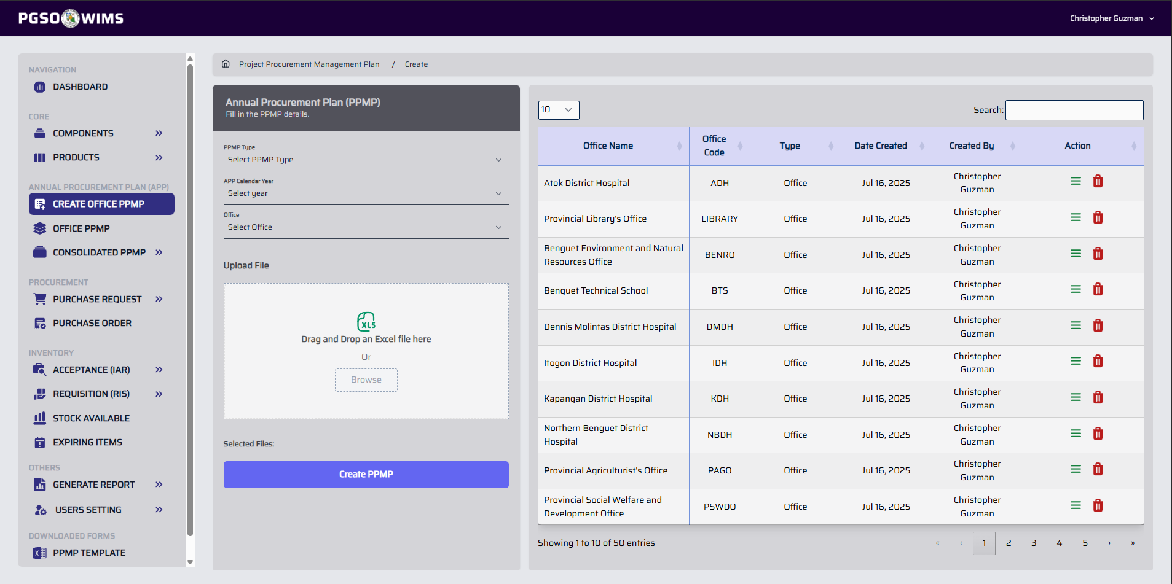


➤ Create Office PPMP
Step 1. Fill up the input fields.
Step 2. Select the excel file to be uploaded. Click the ‘Browse’ button or just drag and drop the file.
Step 3. Click ‘Create PPMP’ button to proceed.
Input Fields:
PPMP Type: Office
Calendar Year: Year of procurement of the prepared PPMP
Office: Department who owns the PPMP
Upload File: Used the PPMP Template downloadable on the system
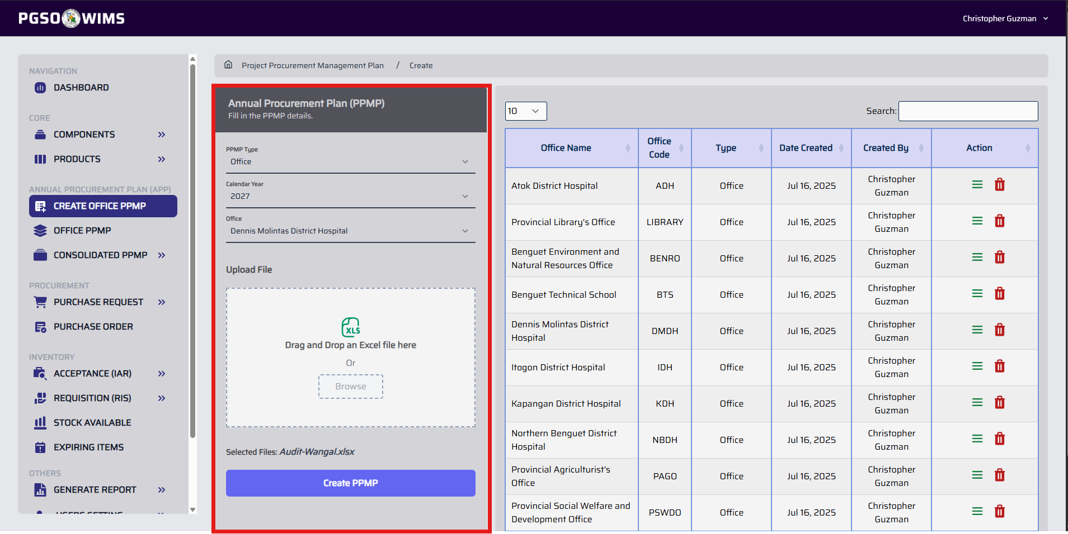
If an office name is missing from the dropdown, this indicates that the office PPMP is already exist on the calendar year selected.
➤ Create Emergency PPMP
Step 1. Fill up the input fields. (Refer to the image above)
Step 2. Click ‘Create PPMP’ button to proceed.
Input Fields:
PPMP Type: Emergency
Calendar Year: Year of procurement of the prepared PPMP
Semester: Timeframe of Procurement
Office: Provincial General Services Office - Secondary
Upload File: Optional, default value is empty
Sample Output
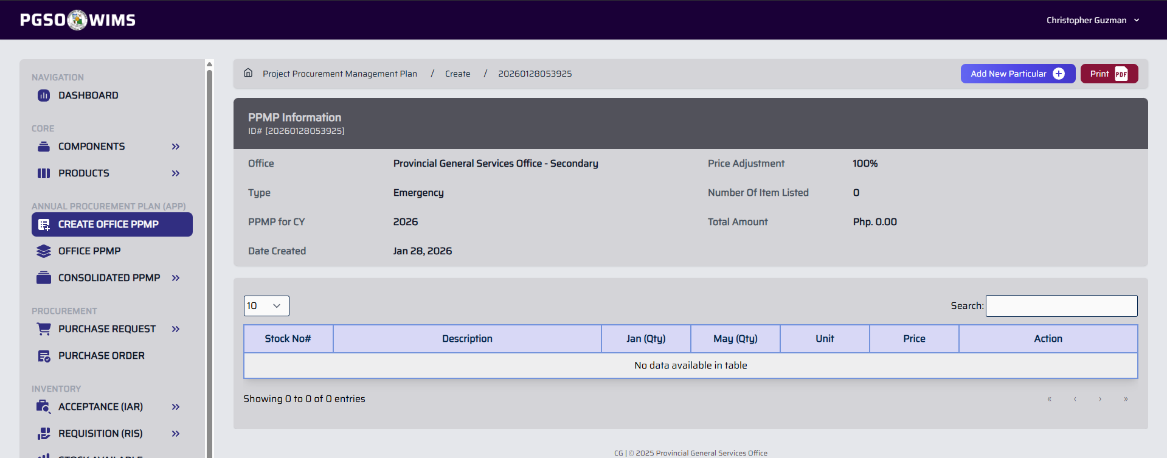
Use this section to add particulars for the Emergency PPMP. (Refer to the Add PPMP Particular Feature of the PPMP module)
➤ View PPMP
Step 1. In the PPMP Transaction table, click the View Icon button within the specific Office column
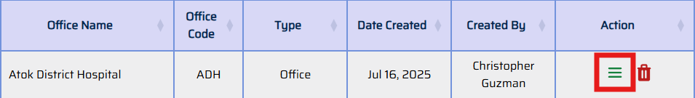
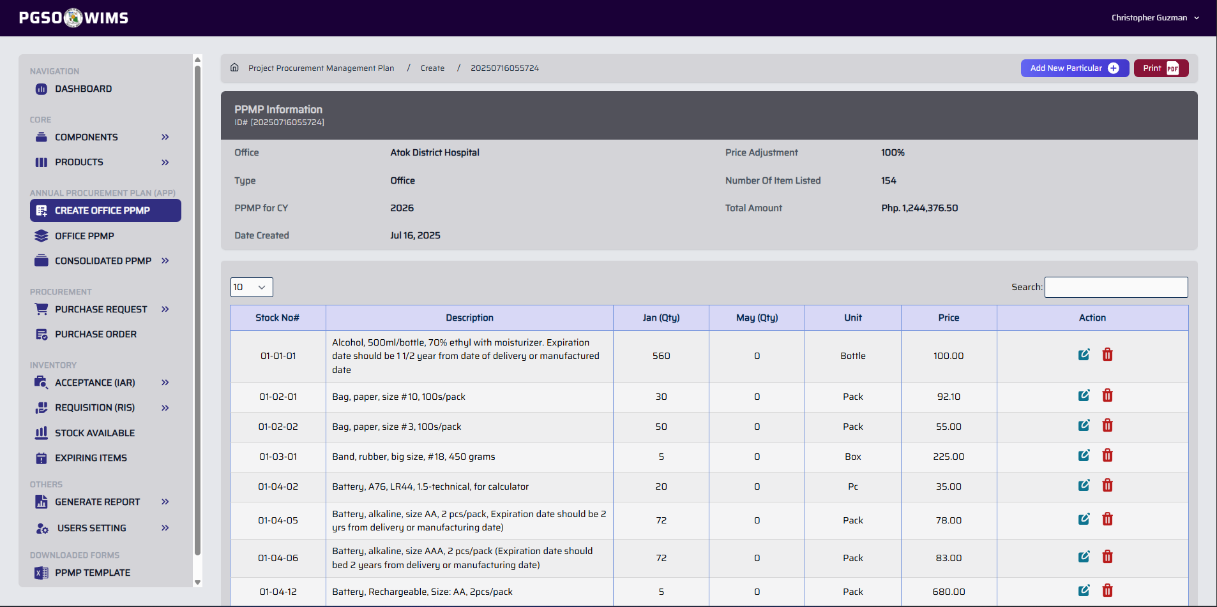
This shows the Summary Overview of the Office PPMP and its requested particulars.
➤ Delete PPMP
Step 1. In the table, click the Trash Icon button within the specific Office column to display the confirmation.
Step 2. Click ‘Confirm’ button to proceed.
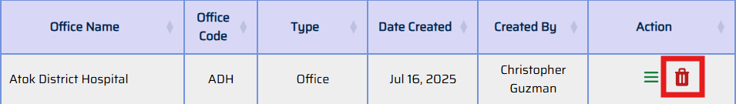
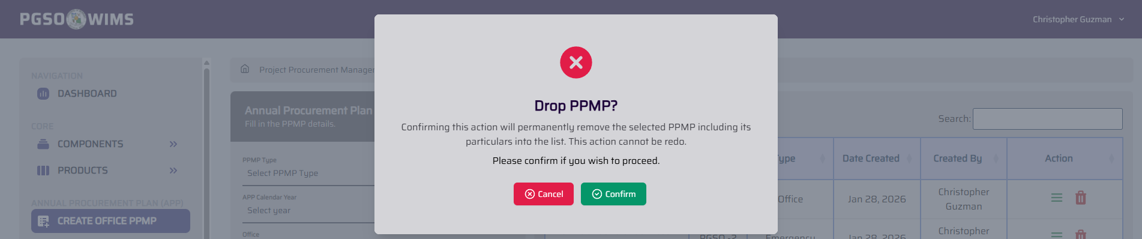

➤ Add PPMP Particular
Step 1. Follow the step of the ‘View PPMP’ feature on how to open the Office/Emergency PPMP.
Step 2. Click ‘Add New Particular’ button to display the form.
Input Fields:
Stock Number: Complete Item Stock No.
1st Semester (Qty): Quantity of the Particular to be Procure on 1st Semester of the Year
2nd Semester (Qty): Quantity of the Particular to be Procure on 2nd Semester of the Year
Step 3. Click Confirm button to proceed.
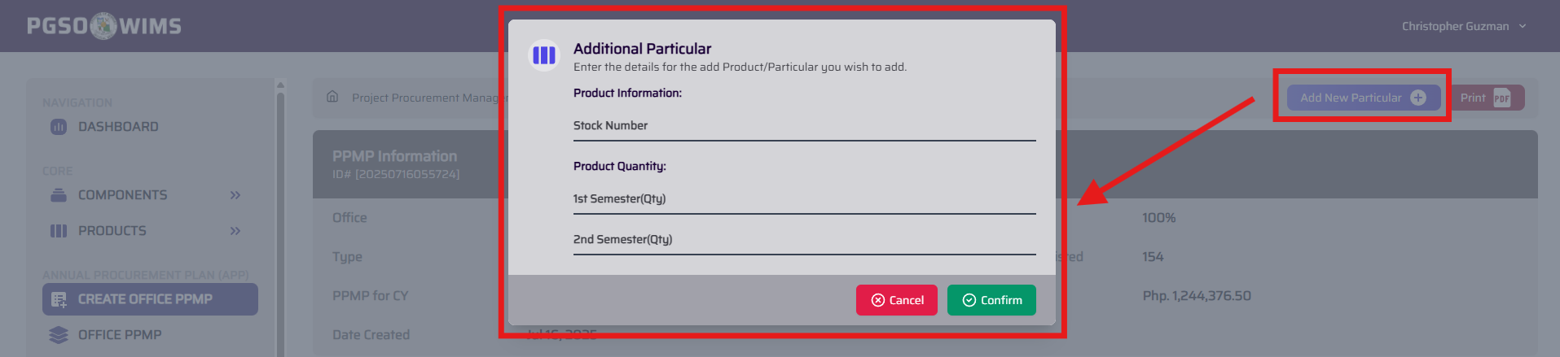

➤ Edit/Update Quantity of a PPMP Particular Quantity
Step 1. In the PPMP particular table, click the Edit Icon button within the specific particular column to display the form.
Step 2. Edit the number of quantities requested on a particular either on 1st or 2nd Semester.
Step 3. Click ‘Confirm’ Button to proceed.
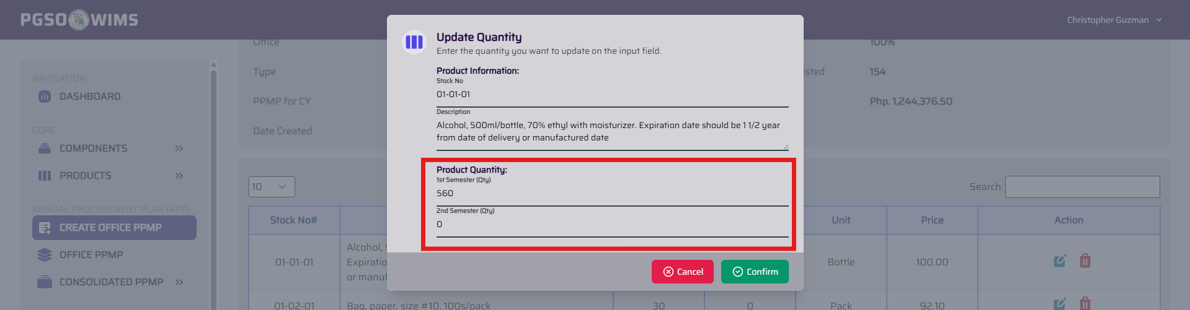

➤ Delete/Trashed PPMP Particular Quantity
Step 1. In the PPMP particular table, click the Trash Icon button within the specific particular column to display a confirmation.
Step 2. Click ‘Confirm’ button to proceed.
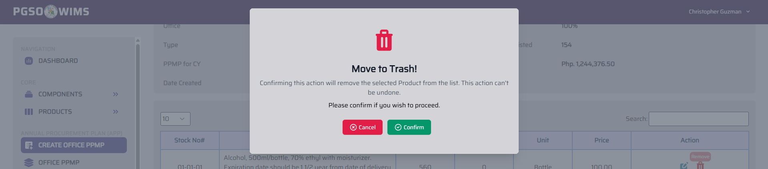
➤ Generate Downloadable Copy of Office/Emergency PPMP
Step 1. Click the ‘Print’ button to generate an PDF File.
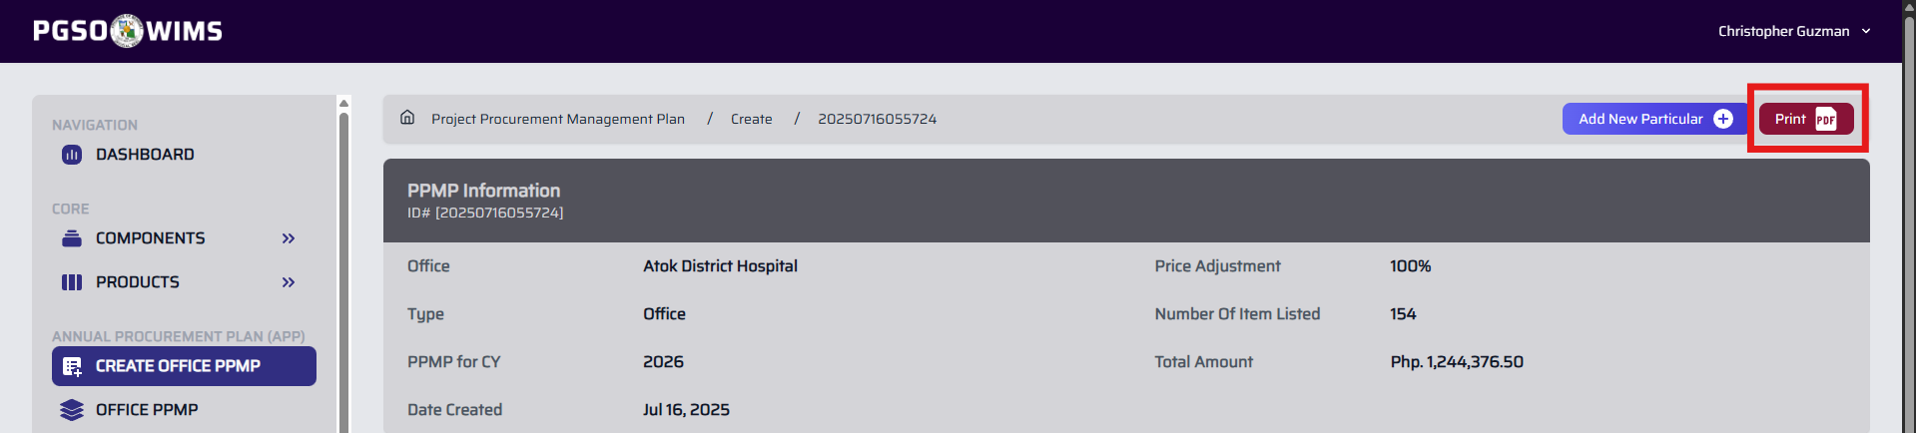

② OFFICE PPMP LIST
➡️ This section displays all created Office and Emergency PPMPs with a status of either Approved or Draft.
Navigate the Page to Office PPMP 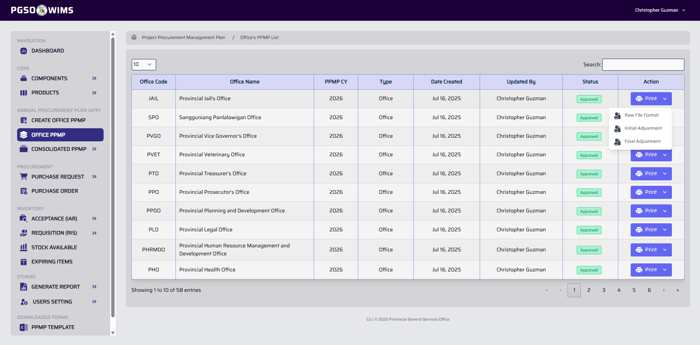 Printing options may differ based on the adjustments that have been applied, status and its type. The Office PPMP status changes once the consolidated PPMP is approved.
➤ Print Office/Emergency PPMP (Original Copy / Raw File)
➡️ This contains the lists of the PPMP particulars in their original form, with no additions, removals, or quantity changes.
➤ Print Office PPMP (Initial Adjustment)
➡️ This contains the list of PPMP particulars where the initial adjustments are applied. (Made after budget deliberation)
➤ Print Office PPMP (Final Adjustment)
➡️ This contains the list of PPMP particulars where the final adjustments are applied. (Adjustment for contingency allotment)

③ CONSOLIDATED OFFICE PPMP
➡️ This section compiles all office PPMPs for Annual Procurement Plan.
# Draft Section
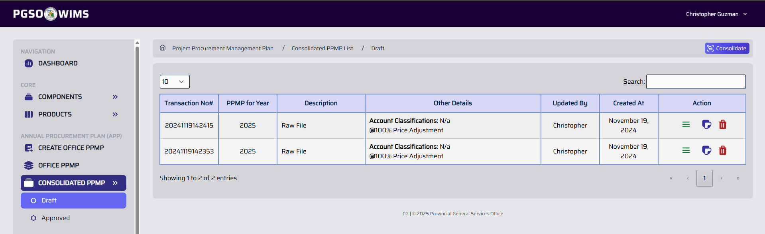
#Key Features
➤ Consolidate Office PPMP
Step 1. Click ‘Consolidate’ button to display a form.
Step 2. Fill up the input form.
Step 3. Click ‘Confirm’ Button to proceed.
Input Fields:
PPMP Type – Type of transaction to be collated
PPMP Year - Year of the selected PPMP Type
Check Account Class to Consolidate - Check all the Account Classes to be Consolidated
Price Adjustment - Use the adjusted price list submitted to the Budget Office
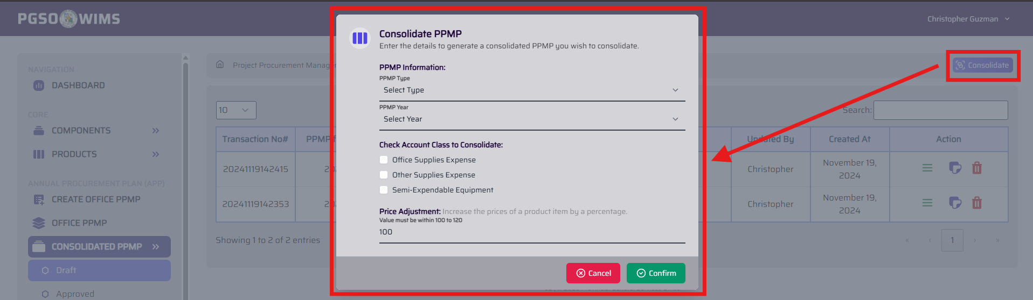
All changes to the office PPMP must be completed before executing the consolidation to ensure that the updates are properly reflected.

➤ Make a Copy of a certain Consolidated PPMP Transaction
Step 1. In the Transaction table, click the Copy Icon button within the specific PPMP Transaction column to display a confirmation.
Step 2. Fill up the input form.
Step 3. Click ‘Confirm’ Button to proceed.
This feature creates a copy of a transaction, preserving the original for reference or fallback while allowing safe revisions.
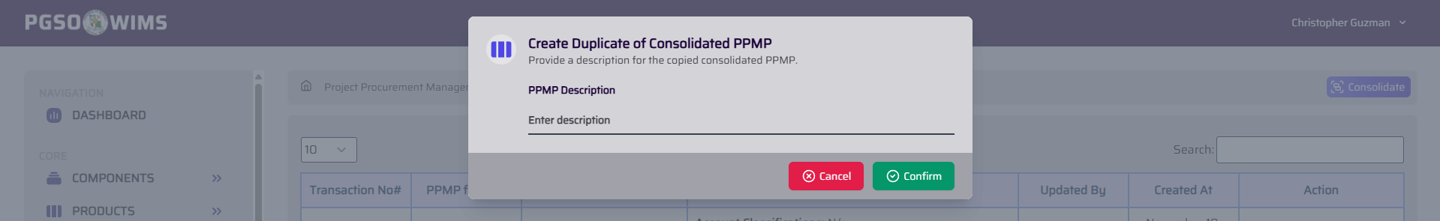

➤ Remove/Delete Consolidated PPMP Transaction
Step 1. In the table, click the Trash Icon button within the specific PPMP Transaction column to display a confirmation.
Step 2. Click ‘Confirm’ Button to proceed.
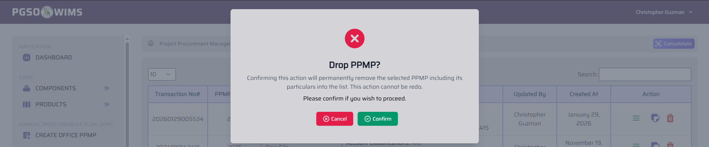

➤ View Consolidated PPMP Transaction
Step 1. In the table, click the View Icon button within the specific PPMP Transaction column.
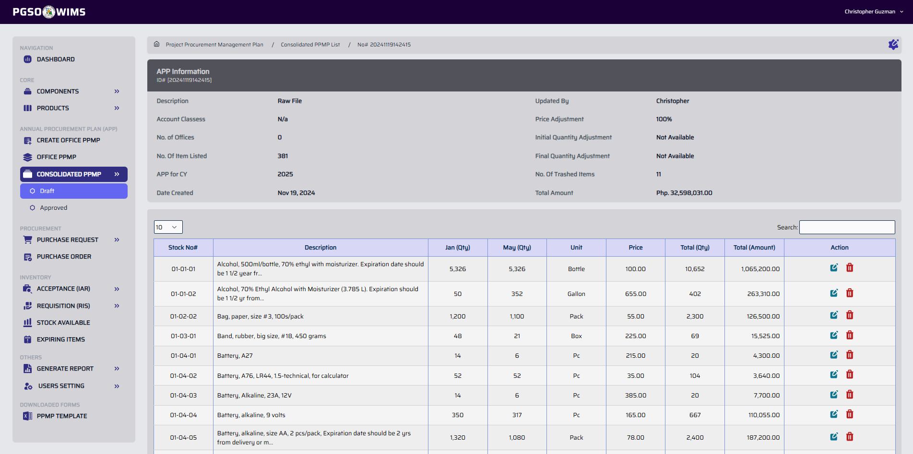
This shows the Summary Overview of the Consolidated PPMP and its collated particulars.

➤ Edit/Update Consolidated PPMP Particular (Quantity)
Step 1. In the Particular table, click the Edit Icon button within the specific particular column to display a form.
Step 2. Edit the quantity of the particular to be procured.
Step 3. Click ‘Confirm’ button to proceed.
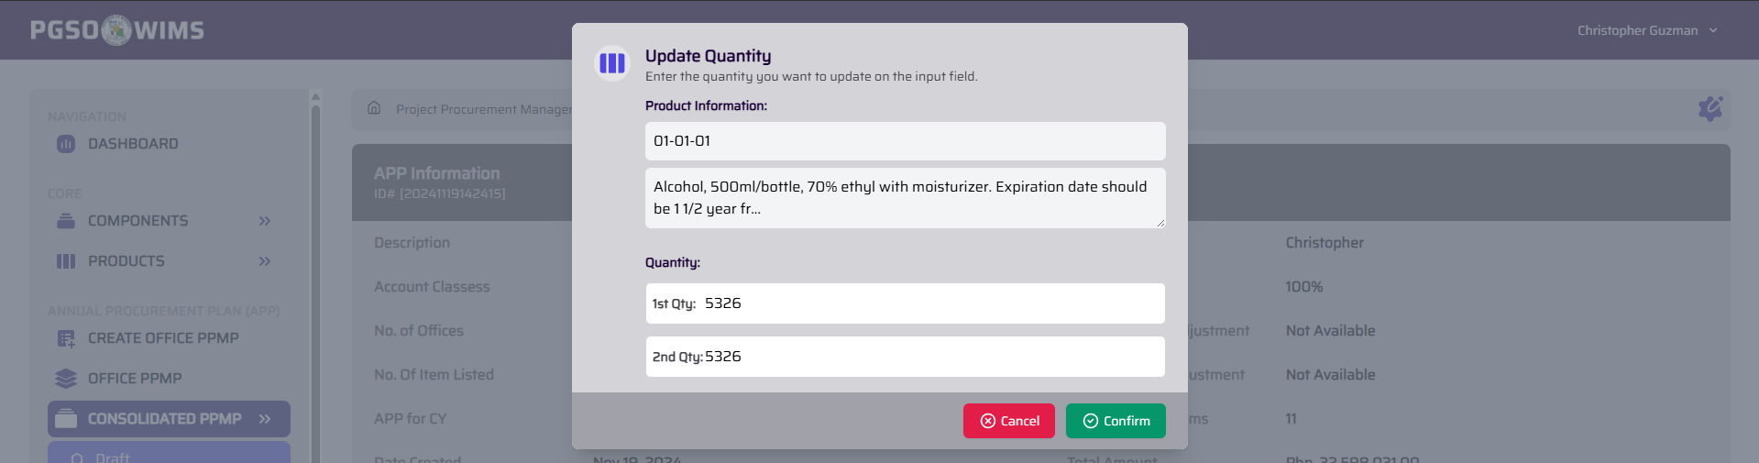

➤ Delete/Remove Consolidated PPMP Particular
Step 1. In the Particular table (Please refer to the above image), click the Trash Icon button within the specific particular column to display the confirmation.
Step 2. Click ‘Confirm’ button to proceed.
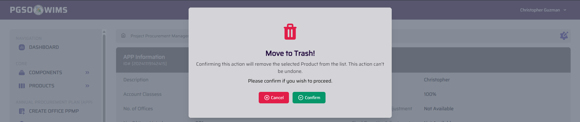

➤ Set Initial Adjustment on Consolidated PPMP
➡️ This initial adjustment is based on the funds allocated by the Budget Office after the budget deliberation.
Step 1. Click the Setting Icon ⚙️ to display a dropdown menu.
Step 2. Click on the Initial Qty. Adj.
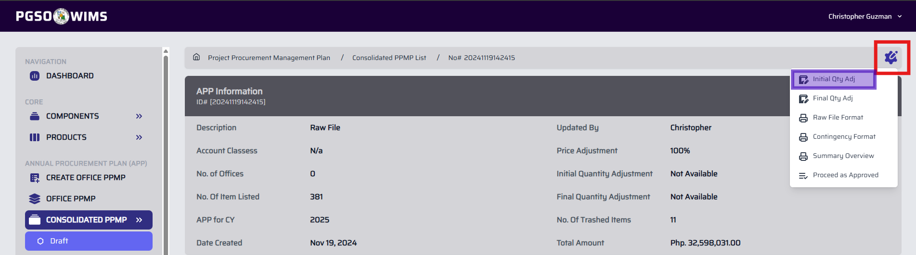
Step 3. Provide the information needed.
Input Fields:
Adjustment type - Group | Custom
Initial Quantity Adjustment - Allocated funds are converted into percentages. Selecting Group applies the same adjustment
value to all accounts. Selecting Custom displays account classifications where individual
adjustment values can be set.
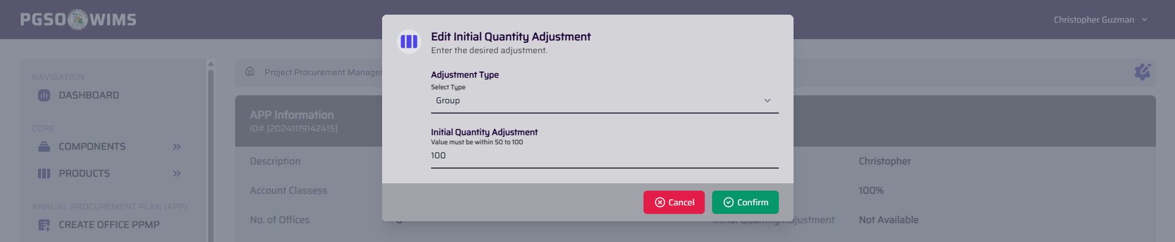
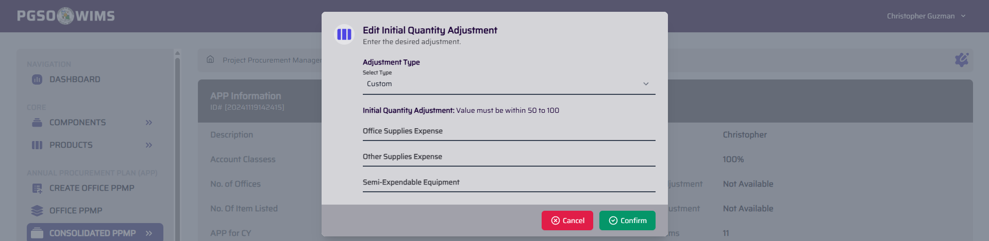
You can adjust the initial value multiple times until it meets the desired amount, as long as the Consolidated PPMP transaction has not been approved. If no initial adjustment is made, the system will use 100 as the default value.
Step 4. Click ‘Confirm’ button to proceed.

➤ Set Final Adjustment on Consolidated PPMP
➡️ The final adjustment is set by the PGSO to allocate contingency funds. It does not change the consolidated quantities or total cost, but it is applied to each office’s particulars.
Formula:
Initial Adjustment = Raw File Quantity * Initial Adjustment Value
Final Adjustment = Initial Adjustment Quantity * Final Adjustment Value
Example:
Product: Bag, paper, size #3, 100s/pack
Timeframe: 1st Semester
Unit: Piece
Raw File as per Request (Qty) | Initial Adjustment is 80% (Qty) | Final Adjustment is 70% (Qty)
1000 | 800 | 560
Step 1. Click the Setting Icon ⚙️ to display a dropdown menu.
Step 2. Click on the Final Qty. Adj.
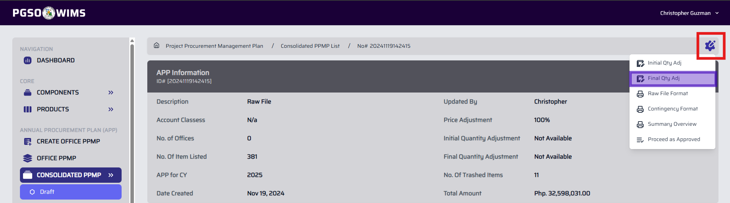
Step 3. Provide the information needed.
Input Fields:
Adjustment type: Group | Custom
Initial Quantity Adjustment: Allocated funds are converted into percentages. Selecting Group applies the same adjustment
value to all accounts. Selecting Custom displays account classifications where individual
adjustment values can be set.
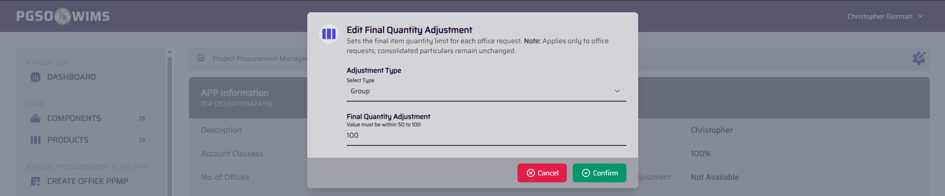
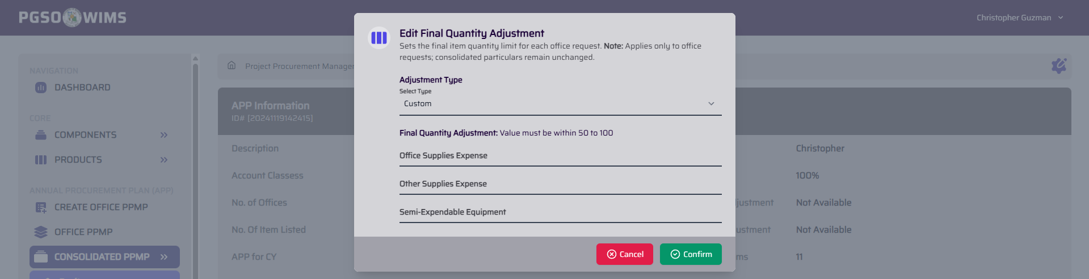
Please put 100 as default value if no adjustment to made on Final Adjustment.

➤ Generate Downloadable Copy of a Consolidated PPMP (Raw File Format)
➡️ This contains the lists of the consolidated PPMP particulars with its total cost.
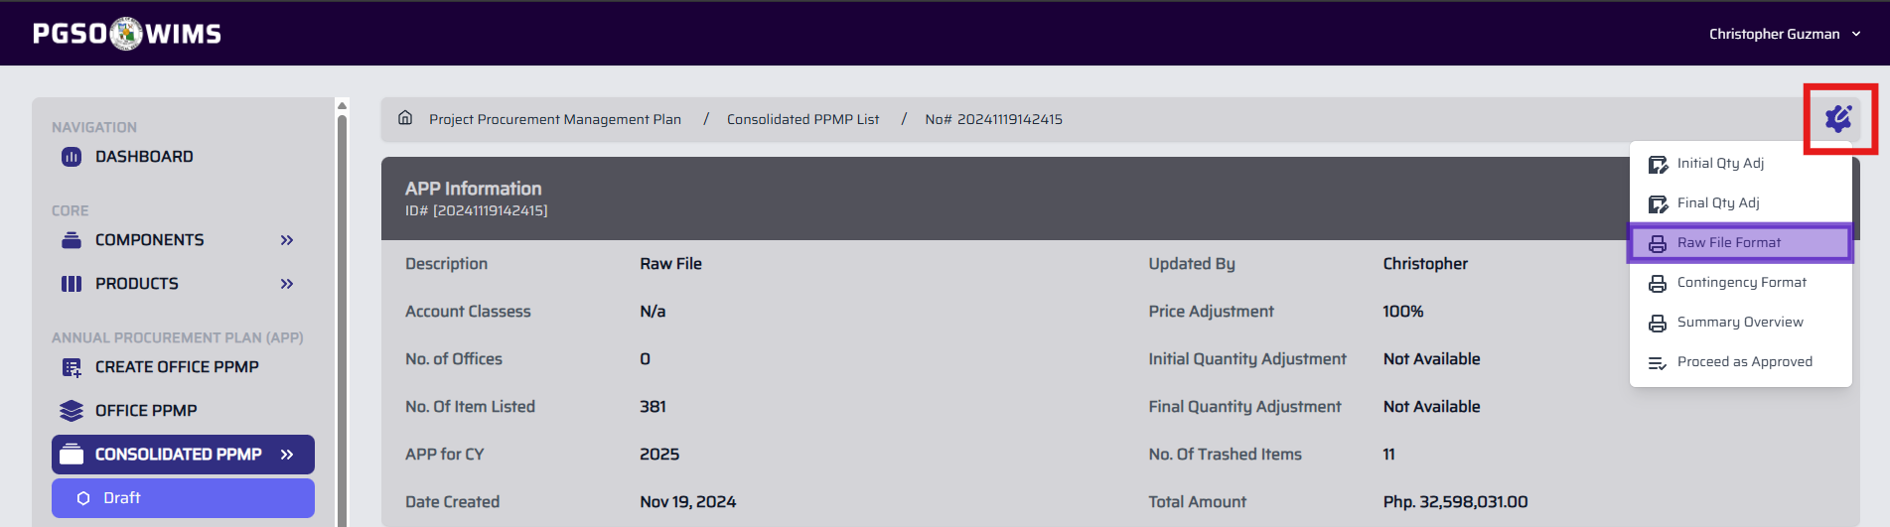

➤ Generate Downloadable Copy of a Consolidated PPMP (Contingency Format)
➡️ This feature generates a pdf file that contains the lists of the consolidated PPMP particulars with its total cost. Contingency fund is added to the template.
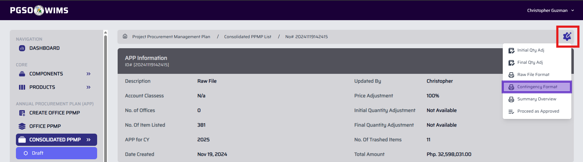

➤ Generate Downloadable Copy of Summary Overview of a Consolidated PPMP
➡️ This feature generates a pdf file that contains the consolidated PPMP particulars and the respective offices that requested each item
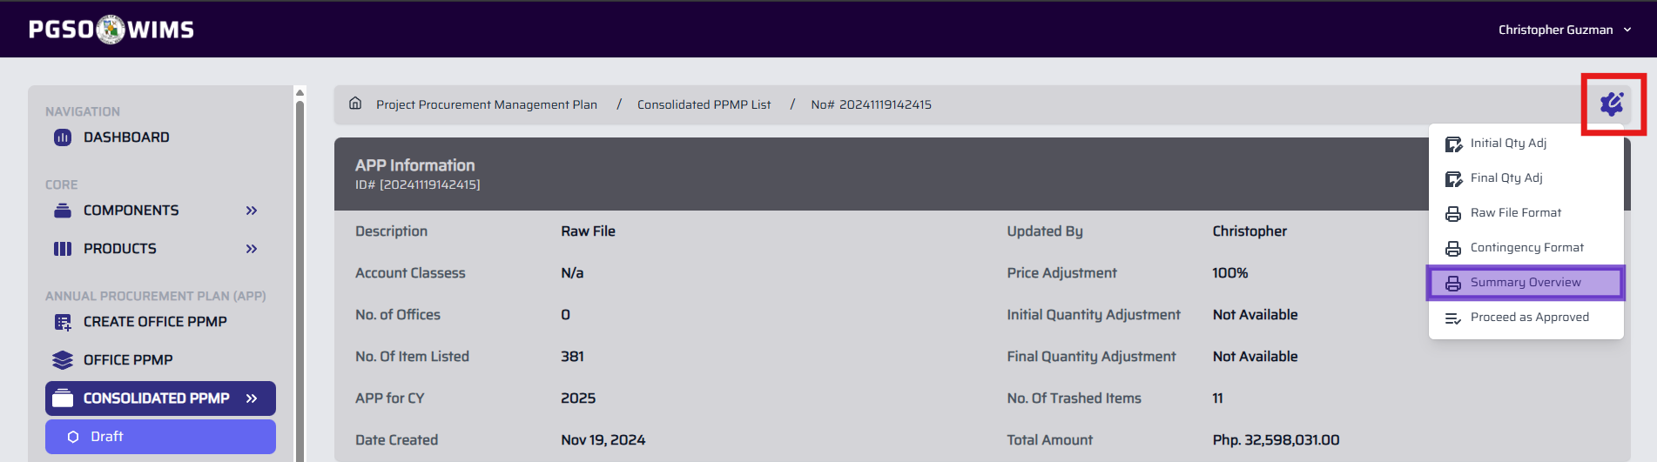

➤ Proceed as Approved
➡️ This feature updates the Consolidated PPMP transaction status to Approved. All adjustments configured for the transaction, including price, initial, and final adjustments, shall apply to all offices under this transaction.
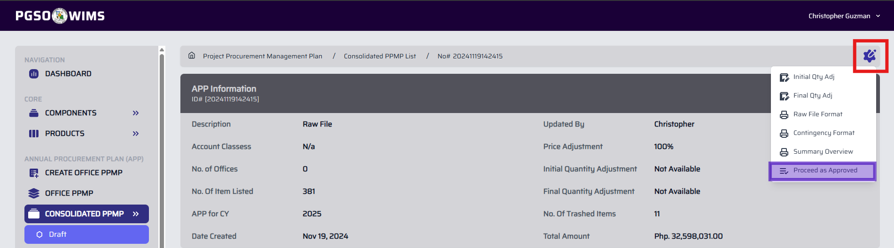
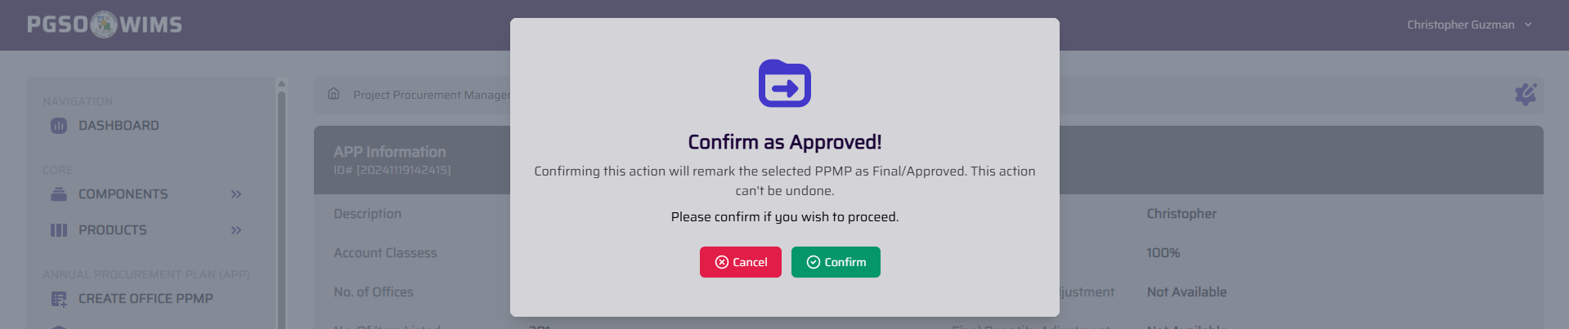

# APPROVED SECTION
➡️ This section lists Consolidated PPMP transactions with Approved status. No actions are available aside from printing.
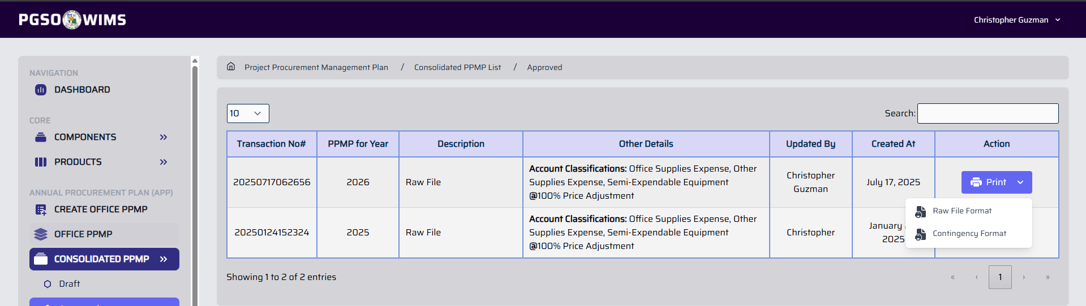
➤ Generate Downloadable Copy of a Consolidated PPMP (Raw File Format)
➡️ This contains the lists of the consolidated PPMP particulars with its total cost.

➤ Generate Downloadable Copy of a Consolidated PPMP (Contingency Format)
➡️ This feature generates a pdf file that contains the lists of the consolidated PPMP particulars with its total cost. Contingency fund is added to the template.

